2021-2022

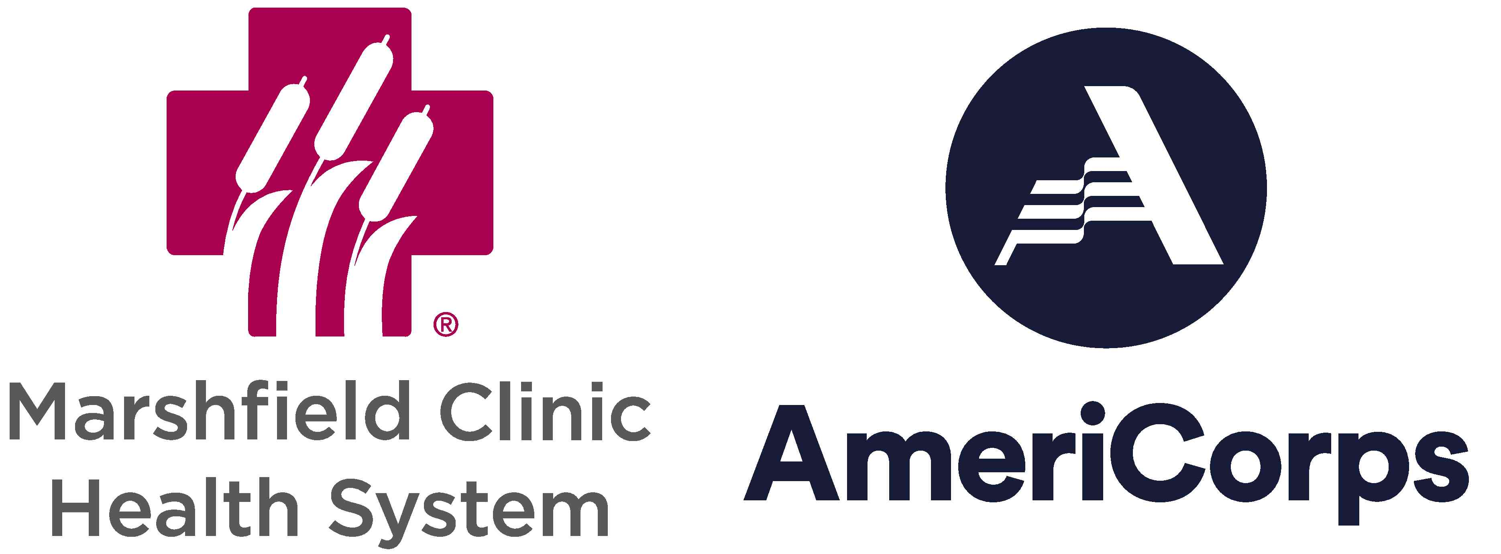

New applicants may apply online here:
https://redcap.mcrf.mfldclin.edu/redcap/birc/surveys/?s=NHJR9MCC78

